**17IE4048 – PROJECT-1**

**PROJECT BASED REPORT**

**ON**

**HEARTPULSE MONITORING AND NOTIFICATION SYSTEM USING ARDUINO**

***submitted in partial fulfillment of the requirement for the award of the degree of***

**BACHELOR OF TECHNOLOGY**

**In**

**COMPUTER SCIENCE AND ENGINEERING**

**By**

HEMANTH SAI GOKARAKONDA (170030384)

JASWANTH GODAVARTHI (170030477)

SIVA SAI KANNEGANTI (170030556)

HARI KIRAN PENDURTHI (170031577)

Under the Esteemed Guidance of

**Dr. S.KAVITHA *PhD***

**Assistant Professor**



**DEPARTMENT OF COMPUTER SCIENCE AND ENGINEERING**

**K L (Deemed to be) University**

Green Fields, Vaddeswaram, Guntur District – 522 502

**EXTERNAL EXAMINER**

**K L (Deemed to be) University**

**DEPARTMENT OF COMPUTER SCIENCE AND ENGINEERING**



**DECLARATION**

This is certify that the project based report entitled **“HEART PULSE MONITORING AND NOTIFICATION SYSTEM USING ARDUINO”** is a bonafide work done and submitted by **Hemanth Sai Gokarakonda (170030384), Jaswanth Godavarthi (170030477), Siva sai Kanneganti (170030556), Hari Kiran Pendurthi (170031577)** in partial fulfillment of the requirements for the award of the degree of **BACHELOR OF TECHNOLOGY** in Department of Computer Science Engineering, KL (Deemed to be University), Guntur District during the academic year **2020-2021**.

HEMANTH SAI GOKARAKONDA (170030384)

JASWANTH GODAVARTHI (170030477)

SIVA SAI KANNEGANTI (170030556)

HARI KIRAN PENDURTHI (170031577)

**(2020-2021)**

**K L (Deemed to be) University**

**DEPARTMENT OF COMPUTER SCIENCE AND ENGINEERING**



**CERTIFICATE**

This is certify that the project based report entitled **“HEART PULSE MONITORING AND NOTIFICATION SYSTEM”** is a bonafide work done and submitted by **Hemanth sai Gokarakonda (170030384), Jaswanth Godavarthi (170030477), Siva sai Kanneganti (170030556), Hari kiran Pendurthi (170031577)** in partial fulfillment of the requirements for the award of the degree of **BACHELOR OF TECHNOLOGY** in Department of Computer Science Engineering, KL (Deemed to be University), Guntur District during the academic year **2020-2021**.

**Dr. S.KAVITHA Mr. V. HARI KIRAN**

**FACULTY INCHARGE HEAD OF THE DEPARTMENT**

DEPARTMENT OF CSE DEPARTMENT OF CSE K L (Deemed to be University) K L (Deemed to be University)

**ACKNOWLEDGEMENT**

The success in this project would not have been possible but for the timely help and guidance rendered by many people. Our sincere thanks to all those who has assisted us in one way or the other for the completion of my project.

           Our greatest appreciation to my guide **Dr. S.KAVITHA**, Assistant Professor, Department of Computer Science and Engineering which cannot be expressed in words for his tremendous support, encouragement and guidance for this project.

           We express our gratitude to **Mr. V. Hari Kiran,** Head of the Department for Computer Science and Engineering for providing us with adequate facilities, ways and means by which we are able to complete this project.

We thank all the members of teaching and non-teaching staff members, and also who have assisted me directly or indirectly for successful completion of this project.

Finally, We sincerely thank my friends and classmates for their kind help and co-operation during our work.

HEMANTH SAI GOKARAKONDA (170030384)

JASWANTH GODAVARTHI (170030477)

SIVA SAI KANNEGANTI (170030556)

HARI KIRAN PENDURTHI (170031577)

1. **ABSTRACT**

The main aim of our project is to provide an automated system to detect and notify the heart pulse of a patient and if there’s any abnormality in the pulse, then it should send the notification to the concerned person or doctor through SMS. Since it is automated, there’s no need of human interaction in between the process. The automation which we have provided is by sending the notifications through online API Twilio. We have used pulse Sensor to detect the heart pulse and an Arduino uno board for the interface and Bolt Wi-Fi module which collects the data and sends it to bolt cloud and AWS will retrieve the data from bolt cloud. Later we have also used SMS API service (Twilio) to send SMS regarding the abnormality of concerned patients. In this way, we are providing a solution to remotely access the heart pulse data of the patients and doctors are benefited the most by our project.

**CONTENTS**

|  |  |  |
| --- | --- | --- |
| **Chapter No.** | **Title** | **Page No.** |
| 1 | INTRODUCTION |  |
| 2 | LITERATURE SURVEY |  |
| 3 | COMPONENETS REQUIRED |  |
| 4 | EXPERIMENTAL INVESTIGATIONS |  |
| 5 | BLOCK DIAGRAM AND FLOW DIAGRAM |  |
| 6 | IMPLEMENTATION |  |
| 7 | EXPERIMENTAL RESULTS |  |
| 8 | DISCUSSION OF RESULTS |  |
| 9 | CONCLUSION AND FUTURE SCOPE |  |
| 10 | REFERENCES |  |

**INTRODUCTION**

This covid-19 pandemic has caused many problems to everyone and especially the most affected ones are the patients. Patients whose heart pulse needs to be monitored regularly by the concerned doctors are affected by this Covid-19 outbreak. There has been a communication gap formed between these patients their concerned doctors/caretakers. Due to the implementation of lockdown all over the world, the situation got worse for the patients. This is where our idea flourished to help those section of patients whose heart pulse needs to be monitored regularly. With the help of the knowledge we gained from the concepts of IOT and its applications in medical field, we have researched and studied many research papers related to our problem statement. After reviewing many papers, finally we have chosen one paper as our base paper and started working on the idea.

Our project “Heart Pulse Detection and Notification System using Arduino “ mainly focuses on the communication gap between the patients and their doctors. The main aim of our project is to establish a communication bridge between the patients and the concerned well takers/doctors. We have used reliable components such as Arduino uno, which is the brains of our system, heart pulse sensor, which detects the heart pulse of the body, and BOLT Wi-Fi module for establishing a connection to send data through the internet. We have used the most reliable VPS service provider which is the AWS VPS to run the program(code) required to detect the abnormality present in the heart pulse. For the notification module, we have used TWILIO as our online API service which sends data to the concerned doctor whenever there’s an abnormality present in the patient’s heart pulse.

We have implemented the following technologies in out project:

1. **IOT** – IOT stands for Internet of Things. IOT describes the network of physical things that are embedded with sensors, actuators, software, etc for connecting and exchanging data with other devices in a network via internet. The applications of IOT are divided into 4 types they are of 4 types they are consumer, commercial, industrial, infrastructure. In the consumer market IOT is mainly used with the products pertaining to home automation or smart home systems. IOT can also be applied to healthcare systems this type is known as H-IOT.  In our project we have used the H-IOT concept to create a healthcare system which monitors and notifies the doctors about the patient’s heartbeat whenever there is an abnormality. But there are several privacy and security concerns regarding growth of IOT.
2. **H-IOT** – H-IOT stands for healthcare IOT. This is undoubtedly transforming healthcare industry by delivering healthcare IOT solutions. These implementation benefits patients, hospitals, companies.

* **IOT for Patients** - IOT devices in the form of fitness bands, smart bands give us various data about the patients. These features can be turned on and off according to the requirement of the user. IOT has changed people’s life’s especially elderly patients by monitoring various aspects of the patients continuously.
* **IOT for Hospitals** – Apart from checking patients health details continuously there are many more advantages of IOT in hospitals. The IOT devices are very useful for tacking medical equipment like wheelchairs, oxygen pumps, and monitoring equipment. Hygiene is also important with the help of IOT devices spread of infectious diseases. IOT can also be used in asset management like environment monitoring, pharmacy inventory control, humidity, and temperature control, etc.
* **IOT for Insurance Company’s** – There are many opportunities for health insurers with IOT connected intelligent devices. Insurance companies can use the data which is captured through health monitoring devices for underwriting and claims operations.

This project Heartrate monitoring and notification system using Arduino con be useful in IOT for Patients and for Hospitals for monitoring patient’s heartbeat at all times.

1. **CLOUD COMPUTING** – Cloud Computing refers to providing on demand availability of Computing resources epically data storage and computing power without any direct management by user. This term is used to define datacentres available to many users over the internet. The clouds may be limited to only one organization or to multiple organizations. The cloud providers generally use Pay as you go scheme. We have selected Aws as our cloud because it has a variety of features and follows a pay as you go scheme the cost of using the cloud is limited and with the limited cost we also get a plethora of features to be used in the project which is deployed in AWS server.
2. **USAGE OF API’S –** API stands for Application Programming Interface. This allows to applications to communicate with each other. One of the main requirements of this project to send SMS whenever there is an abnormality so in this case, we use a SMS API service called Twilio. Whenever there is an abnormality detected in the AWS server with the help of a program, we can access Twilio and send SMS about the status of the patient.

**LITERATURE SURVEY**

* **Low Cost Heart Rate Portable Device for Risk Patients with IOT and Warning System**

In this paper it is designed with a less price of compact device to heart rate monitoring for threat patients with internet of Things based and short message service notification as a warning system. Wi-Fi module has a function to communicate the web server gateway and pulse sensor. The Wi-Fi module has function to interface with a web server gateway and a heart pulse sensor. Patients and doctors can see heart rate information through the website in real-time. The patient heart rate is below 60bpm and greater than 100 bpm and the patient

having the emergency button. The heart pulse sensor is rate which it is converted into the bit per minute. The data is saved using the transmission control protocol and internet protocol communications. The data which can be seen by the doctors and patients through the website in the real time applications. The warning system will send the message to the doctors by using the TCP IP communications. The heart rate is displayed in a screen which the screen is connected to the breadboard. And the heart rate is also displayed on the website portal and can see the information at any time on the website.so that if the patient having an emergency problem there is a emergency button which is used for the patient’s emergency to go the hospital.

* **Smart Health Care Monitoring Using IOT**

**Shubham Banka, Isha Madan, S.S.Saranya**

IOT plays a crucial role in health care providing better medical facilities to patients and doctors and for hospitals remotely without any human interaction. The proposed outcome of this paper is to build a medical system that helps to patients who don’t have hospitals in their areas and they can access our system remotely here the raspberry pi micro controller collects the data of the patients remotely via internet and gathers the health reports of the patients. This system also measures the heart pulse and blood pressure and it will send the collected information of patient’s health to their family members and doctors so they can keep monitoring the patients’ health status and full medical information remotely in case of any medical emergencies the collected information of the patients health data can be analyzed and predict disorders such as heart attack in preliminary stage itself using the data of patients

health status and here we proposed an automatic system to monitor the patient’s body temperature, heart rate, body movements and blood pressure remotely. The sensors that are

placed on the patient’s body measures and takes the readings of the patient and will send the

collected data and signal to raspberry pi. The Raspberry Pi is a credit card-sized single-board

computer which is operated on Linux software and all the sensor measures the reading and

sends the data via raspberry pi to consultant doctor and patient remotely without any third

person interaction.

* **A smart system for remote monitoring of patients and SMS messaging upon critical condition**

**Angad Kale, Siddharth.K. Kaul, Debi Prasad Das and S. Raghunath**

This paper proposes a smart system which will monitor the patient’s condition and health status in the hospital and if there is any abnormality in patient it will immediately send an SMS message to the patients mobile phone upon his abnormality of his health. This system can be used to monitor various patient’s health status and their conditions in hospitals. This system consist of supervisory computer, Wi-Fi module and detailed data of the patient’s kept near the patient’s bed and it will monitor the patient’s accurately if there is any abnormality or critical condition of the particular patient it will send the concerned data to the doctor, nurse through the GSM messaging module to alert the situation of the patient and one of the serial ports near patient’s bed will have TTL interface as it is connected to the F-bus and to any mobile phone. And any GSM modems can also be used in place of normal cell phones and the advanced technologies and data used here are ZigBee, RS485, GSM and it also involves a server computer and microcontroller here it collects the data from the various sensors like body temperature sensor, ECG sensor and body pressure sensor and it collects and measures the data of the patient and if there is any disorder or critical condition of the patient it will alert the doctor and patient through an SMS message which is sent by using GSM module. This system is very useful in hospitals where patients locates far away from hospital areas can be able to contact the doctor or notified easily by this system.

* **Development of Smart Healthcare Monitoring System in IOT Environment**

**Md. Milon Islam Ashikur Rahaman, Md. Rashedul Islam**

IOT plays an crucial role in health care providing better medical facilities to patients and doctors and for hospitals remotely without any human interaction and health care monitoring systems in hospitals and many other health care hospital and health centers as they have experienced a huge growth in monitoring systems. IOT produces the progress health care monitoring system from face to face consultancy to telemedicine. This paper proposes a smart health care monitoring system using IOT which monitors the patient’s health status and store the data and sends the data to doctor so they can check the data accurately and responds to the critical condition of the patient. In this system we used five sensors that are heartbeat sensor, body temperature sensor, room temperature sensor, co sensor and co2 sensor all these various sensors are used to capture the patient’s data. If there is any critical condition of the patient it conveys the data via a portal to hospital and medical staff where they can monitor the patient and check their health status and current situation of the patient and the collected data are sent via an ESP32 module and it will send the data to a gateway server. Thing Speak is used for graphical interpretation and will display the all collected data and it shows the current status and process of transaction and the HTTP protocol provides easy response between Wi-Fi module and web server by this way we send the information through internet.

* **Heartbeat and Temperature Monitoring System for remote patients using Arduino**

**Ruaa Shallal, Abbas Anooz**

This paper describes the working of IOT in a wireless heartbeat and temperature monitoring system and considering a microcontroller (Arduino uno). Most of the monitoring systems that are used in today’s world works in offline mode and we can design it in such a way that it measures the patient’s data remotely in real time. This method consists of sensors which are used to measure the heartbeat and temperature of a patient and measure the readings and send the data to consultant doctor and patient which is controlled by microcontroller. Both the readings are measured and displayed in an LCD screen. Wireless system which is used to monitor and transmit the measured data from remote location. The heartbeat sensor measures the heartbeat for specific time and will estimates beats for minute while the temperature sensor measures the temperature of the patient’s body and both these readings send to the microcontroller for transmission to receiver end. Finally, this data will be displayed in an LCD screen and this system will be available in less cost with great effect. The various sensors Arduino ATmega328, Temperature sensor LM35, Heart Beat Sensor LM358, nRF24L01 Module and an LCD display with a power supply these measure the data and send the data to microcontroller which will monitor and display the result on an LCD monitor accurately .

* **Developing IoT Based Smart Health Monitoring Systems**

**Ashikur Rahaman, Muhammad Sheikh Sadi, Sheikh Nooruddin**

IOT based health care monitoring system is a smart care monitoring system where patients can be monitored 24 hours remotely. IOT plays a crucial role in health care providing better medical facilities to patients and doctors and for hospitals remotely without any human interaction. Health care monitoring systems in health care hospital and health centers have experienced a huge growth in monitoring systems and it is also changing the infrastructure of the existing technologies. There are many types of projects created to monitor the patient’s health remotely. This paper proposes a smart health care monitoring system using IOT which monitors the patient’s health status and store the data and sends the data to doctor so they can check the data accurately and responds to the critical condition of the patient. Here we use different sensors to collect the data from patient’s body such as ECG sensor, pulse rate detecting sensor, temperature sensor, respiration sensor, RFID sensor, gluco-meter sensor, body position sensor and co2 sensor. All these various sensor collects the patient’s data and send the data to microcontroller and these data which is collected is stored in a cloud and via using the help of internet and some third parties API’s this data will be sent to doctors and health care organizations and this received data of a particular patient will be monitored by doctors and hospitals as they can monitor the patients health status 24 hours accurately and take safety measures before any critical situation occurs. In this way IOT play a huge role in medical and health care organizations.

* **Continuous Heart Rate and Body Temperature Monitoring System using Arduino UNO and Android Device**

**Asaduzzaman Miah, Hussain Kabir,Siddiqur Rahman Tanveer ,M.A.H. Akhand**

An integrated portable device for continuous heart rate and body temperature monitoring is presented in this paper. Cardiovascular diseases are increasing day by day; therefore, accurate, inexpensive and portable heart rate and body temperature are essential for taking timely action. Such a device is especially important in a situation where there is no doctor or clinic nearby (e.g., rural area) and patients are unable to see their true condition. The enhanced version of this tutorial contains the Arduino UNO microcontroller system, transfer system and Android-based application. The app provides simultaneous heart rate and temperature information obtained from a mobile device in real time and displays it via an instantly connected Android app. The upgraded system is more expensive at a lower price compared to other advanced devices due to using the available Arduino UNO and smart phone as an Android device. The improved device is shown acceptable results compared to other measurement devices.

* **Analysis of Heart Rate and Body Temperature from the Wireless Monitoring System Using Arduino**

**Mohammad Dabbagh**

The state of the Intensive Care Unit (ICU) ward tends to be much larger since

ward patients are often critically ill patients. These patients need them

intensive care by nurses and doctors because their condition is not very stable.

Therefore, nurses and doctors need to monitor them frequently. So, the idea of ​​this

the monitoring system primarily reduces the workload of nurses by reducing the frequency of monitoring. This a carefully designed monitoring system to make them aware of their patient that way, they can reducing the risk of patients being treated. This monitoring system uses microcontroller (Arduino Uno) connected to laptop via Bluetooth to transmit defendant heart rate and body temperature data. This data made sense with the Heart Rate Grove sensor and the LM35 temperature sensor. Details processed and displayed a full-time laptop continuously. A different color LED was used as a reference in inform the respondent's heart rate or body temperature whether it was high or low status as a warning. In a young adult who has a fever, it shows an effect of 81 bpm of heart rate and 37.63oC body temperature by 3.83% and 0.65% Mean Absolute Percentage Error (MAPE) respectively. This monitoring system has been successfully developed and has been able to show the defendant's heart rate and body temperature data every minute as well able to perform independent surveillance tasks in the future.

* **Web-based remote monitoring of infant incubators in the ICU**

**D.I. Shina, S.J. Huha, T.S. Lee , I.Y. Kimc**

A real-time web-based system, management, and monitoring to test the temperature and humidity inside infants using the Intranet was developed and incorporated into the Department of Infant Care (ICU). We have created a sensing system with temperature and humidity sensors and measuring module in each incubator, connected to the web-server board via RS485 the harbor. The system transmits signals using standard TCP / IP web for users access the system on any personal computer connected to the Internet at the hospital. Using this method, the system collects heat and humidity data that is transmitted from the RS485 port measurement modules on the web server board and creates a web document containing this data. The system manager may end up in one place monitor the oversight of conditions in all conjunctions while sitting inside the baby The ICU in the work space is equipped with a personal computer. The program can be set to monitoring unusual situations and sounding an alarm signal heard as a sound or light in the measurement module connected to a related incubator. If the system arranged with a large number of incubators connected to a single control a monitoring station, will improve ease of use and ensure meaningful development responding to events that require intervention.

* **Applying Telecommunication Technology to Health**

**James C. Lin**

Telemedicine is ready to provide care for disadvantaged communities e areas of diagnosis and management of difficult conditions and screening of patients in remote areas. Provides great potential benefits to patients also enhances the skills of local doctors. It is an effective method to provide basic professional consultation

in the remote emergency department. By reducing the need for hard transfers on

high hospital, great benefits can expected. Although the conclusions of all the subjects

updated to recommend the use of telemedicine, the currently available evidence is not enough to suggest its widespread implementation. Extras studies are needed to determine when and when with which parties and conditions telemedicine is an effective delivery method medical services, and if so cost effective. As wide and wide

of telemedicine applications increasing, there are several technical and clinical problems that require intensive research. In any case, it seems deploy telemedicine on a broad basis of poorly served communities, where possible be the only logical way.

* **An IOT-Based smart framework for human heartbeat rate monitoring and control system**

**Dr. Maria, Liz Crespo**

This research paper outlines the design and implementation of Internet of Things (IoT) a framework based on a program to monitor and control a person's heartbeat. Complete studying the various techniques and techniques used to control heart rate

checked. The proposed system was developed and used on a variety of food boards

integrated, connected, and tasting parts of the system. Test results obtained from

the type used was found to be accurate, as the system was able to hear and read

its heart rate for its user and transmits sound information over the internet. Parts of the system they were sold on a loaf of bread and placed in a plastic container with a heartbeat extended, to cut the tip of a system user finger. Test results show

that the heart rate of children under 17 is between 65 to 115 beats per minute

(BPM) and heart rate for an adult between the ages of 17 to 60 is 60 to 100 BPM. In

in addition, the heart rate of adults 60 years and older, their heart rate the average is between 65 and 120 BPM respectively. These findings are in line with the national government in the field of medicine. In addition, this research paper, presents a flexible approach is reliable, and is the secret of the heart rate monitoring and control system using the sensor network and IoT technology that can be disseminated in the medical field to assist medical personnel they do their job easily.

**COMPONENTS REQUIRED**

As one of the aim of this project is to provide the implementation at low cost we tried to complete the project using minimal but rather very much effective components. The components which we used are:

1. **Arduino Uno Board:**

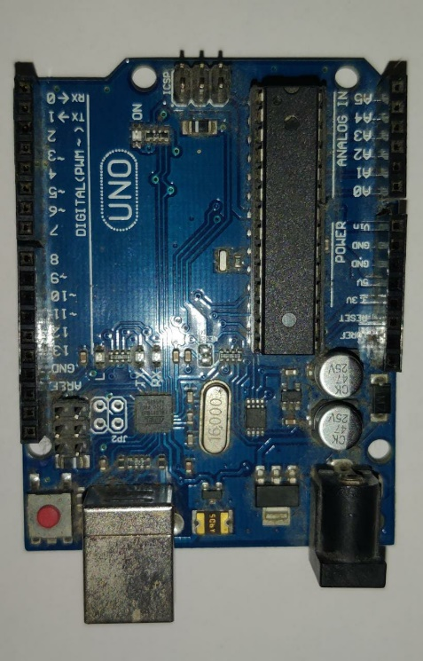

Arduino Uno Board is an open-source microcontroller board based on ATmega328P microcontroller which is developed by Arduino. The Arduino Uno board contains a set of pins which are used for input/output purposes. There are 14 digital I/O pins and 6 analog I/O pins. This board can be programmed by using Arduino IDE by connecting the Arduino to a laptop by using a Type B USB cable or an external power source.

1. **Pulse Sensor:**

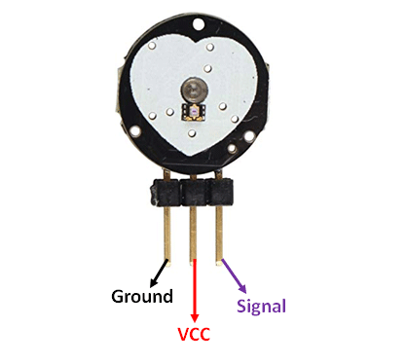

Pulse Sensor is a plug and play device which is designed to work with Arduino for calculating the heartrate of a patient. There are two surfaces and three pins to the sensor one side contains the LED and ambient light sensor on the other surface we have a circuit board containing noise cancellation and amplification. The three pins are ground, VCC (power supply), signal. When we place the sensor on our finger tip the sensor detects the vein which is present in the finger and whenever there is a blood flow change in the veins, we can calculate the heartbeat as well.

1. **Bolt IOT Wi-Fi module:**

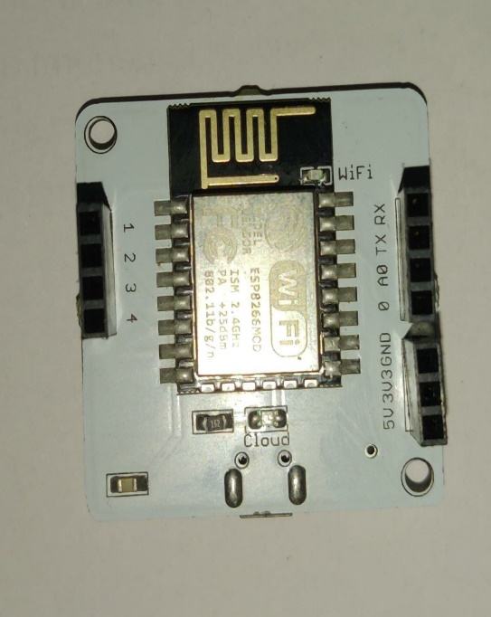

This Wi-Fi module acts as an interface to connect the hardware components to the cloud. This bolt Wi-Fi module is secure and fast. Here there are a few I/O pins which can used according to the user’s requirements. There are two lights present which indicate the working of the module. Green light indicates that the module is connected to cloud and orange light indicates that the Wi-Fi is on.

1. **Jumper Cables:**

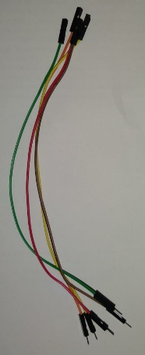 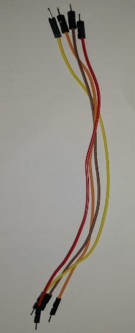

In this project we use M-M, M-F jumper cables which are used to connect various components to the Arduino Uno board.

1. **Breadboard:**

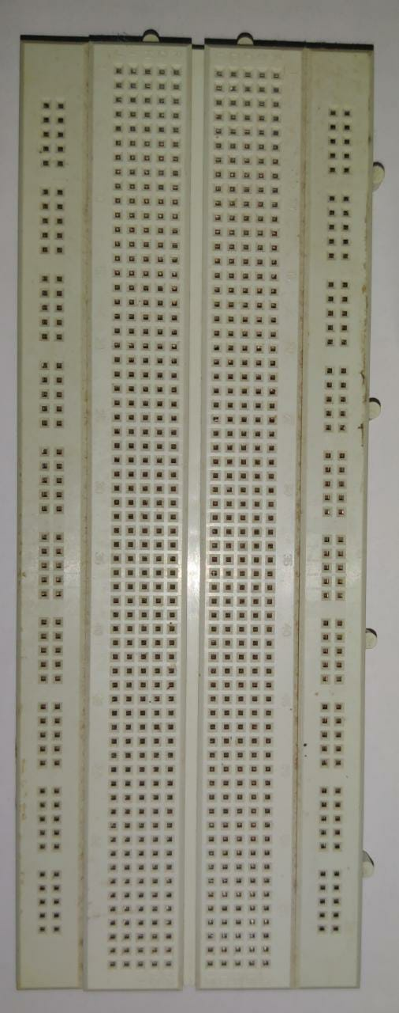

This breadboard is an extension which can be used to connect various components together. Instead of connecting by using soldering we can temporarily connect the components using a breadboard.

**EXPERIMENTAL INVESTIGATIONS**

**EXISTING MODEL:**

We as a team have referred a lot of research papers and finally considered 12 papers as our main reference papers for our project. Out of which, we have taken one paper as our base paper which is “Remote Patients Monitoring System (Heartbeat and Temperature) using Arduino”. From the base paper, we have understood that they have implemented the concept of IOT in the medical field. They have used body temperature sensor which is “MLX90614” to detect the temperature of the body (person) and Heartbeat sensor (KY039) to detect the heart pulse of the person. These two sensors come under the data sensor module of the tele-health monitoring system. The information in this module is then collected and sent to the data processing unit of the system. Here it analyses and sends the data to the data communication unit. In this unit, they have used LCD and given a power supply to it. Using this LCD as the output unit, they have provided the detected results of heart pulse and the temperature of the body.

Disadvantages:

1. It is not automated.
2. There is no notification system to this project i.e. there’s no means of communicating the results remotely.
3. Data is not stored i.e. there is no scope for the previous records to store in the system.

**PROPOSED MODEL:**

We have taken these factors and tried to eliminate them. Our project “Heart pulse monitoring and notification system using Arduino” mainly concentrates on the communication gap between the patient and the concerned doctor. We tried to reduce the gap between them by introducing the concept of notification system to the already proposed model. For this purpose, with the help of the knowledge we gained from the IOT course, we have used TWILIO as our online SMS service to send notification regarding the heart pulse of the patient. We have used the similar sensor to detect the heart pulse of the patients which is the KY039 heart pulse sensor. We have used Arduino UNO as our main microcontroller of our project. Using a BOLT WIFI module, we have automated our system by establishing a connection with the internet through this module. Later we have used AWS VPS services to run our system and to that the notification system is attached. Our system checks for abnormality present in the heart pulse of the patient and if there is any abnormality observed then our system sends the message to concerned doctor in the form of SMS.

Advantages:

1. Our project is fully automated.
2. Our project has a notification system which sends the message to the concerned doctor/person regarding the abnormality.
3. Since it has VPS service such as AWS and API service such as TWILIO, the previous data records are stored in the cloud. So that the doctor can review them later in the future.
4. Our system is cost efficient. We have tried to minimise the cost of our system as much as possible.
5. Since we have used online API service, there is no need of additional usage of GSM (sim) in our system to send message.
6. We have used AWS Virtual Private Server which is very reliable in market.
7. Our project is user friendly.

We have gathered, studied, understood, and then found the loopholes in our base paper. We have tried to reduce those loopholes as much as possible by improvising the idea and implementing the whole system automatedly.

**BLOCK DIAGRAM AND FLOW CHART**

* **BLOCK DIAGRAM:**

* **FLOW CHART:**

**IMPLEMENTATION**

**5.1 – INTERFACING PULSE SENSOR, WIFI MODULE WITH ARDUINO**

* First, we should connect the Arduino Uno board to the computer and in the PC, we should have installed Arduino IDE software for writing the code and pushing it into Arduino.

* After installing software and connecting the Arduino we must connect the pulse sensor to the Arduino Pins. A diagram is showing below about how the interfacing should be done.

* Now we must connect the Arduino Uno to a Wi-Fi module to transmit the data which we receive from the pulse sensor to the cloud. Here we used BOLT IOT Wi-Fi module.

* After interfacing is done, we have to write a code to calculate the pulse value from the sensor when a finger is placed on it. The code is given below

**Code**:

#include<SoftwareSerial.h>

int pin=0;

int led=13;

int signal;

int threshold=550;

int S;

SoftwareSerial mySerial(10, 11);

void setup()

{

pinMode(led,OUTPUT);

Serial.begin(9600);

mySerial.begin(9600);

}

void loop()

{

signal = analogRead(pin);

S=(signal/8)-64;

Serial.print("your heart beat is : ");

Serial.print(S);

Serial.println("BPM”);

mySerial.println(S);

if(signal > threshold)

{

digitalWrite(led,HIGH);

}

else

{

digitalWrite(led,LOW);

}

delay(1000);

}

**5.2 – Connecting the Hardware setup to AWS VPC**

* Create an AWS Educate account to create and run an AWS VPS.

* After creating the account login to the AWS Educate environment and click on AWS Console.

* After opening AWS Console. From the services present their search and select launch a virtual machine with EC2.

* Now, select Linux server from all the options available and select all the requirements of your virtual private Linux server.(ex- Instance Type, Storage, Security,etc) and select Review and Launch. Your Linux server will be launched. Here a key will be generated which will be used to connect to the server later.

* After the instance is launched. Click on the new instance id and select connect various details regarding connection process are displayed.

* After clicking the connect the following details are displayed go to SSH client.

* Now by using Putty we have to connect to the server we created in AWS. Firstly using the PuttyGen we convert the .pem key which we get from AWS to connect to Putty to a .ppk file which can be used by Putty to connect to the server.

* Now open putty and select the .ppk key which we converted by using PuttyGen. From the AWS Connect window select Hostname of the instance which we create. Now in Putty go to Connection -> Data and copy paste the username to Auto-login username.

* Go to SSH -> Auth in Putty and upload the converted putty key file into the private key file authentication which is present in Putty.

* Now go to Session and Click on Open. You will be connected to the linux server to the which is present in AWS.

* The Linux server is created and configured now we can use this Linux server for the execution of the project.

**5.3 – SETTING UP OF TWILIO FOR SMS**

* Create a Twilio account.

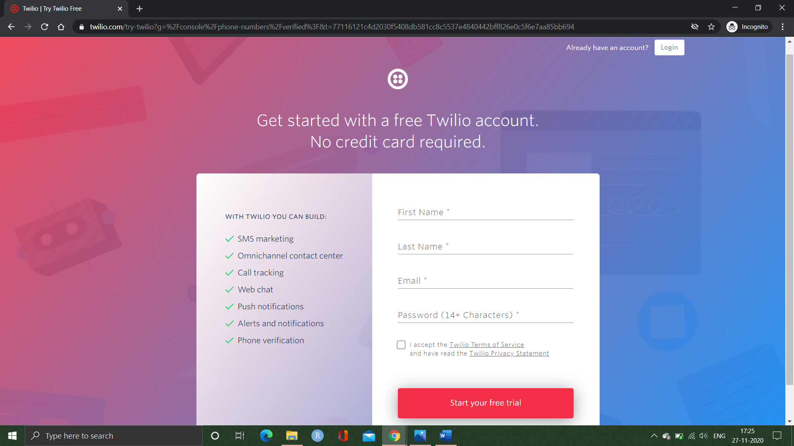

* Get a trail number to send the messages to participants

* Collect the mobile numbers of people whom you want to send the SMS (if there is abnormality) and add the numbers in verified caller id’s as shown

* Go to API explorer and select programable messaging from drop down menu and click on messages.

* Click on create message.

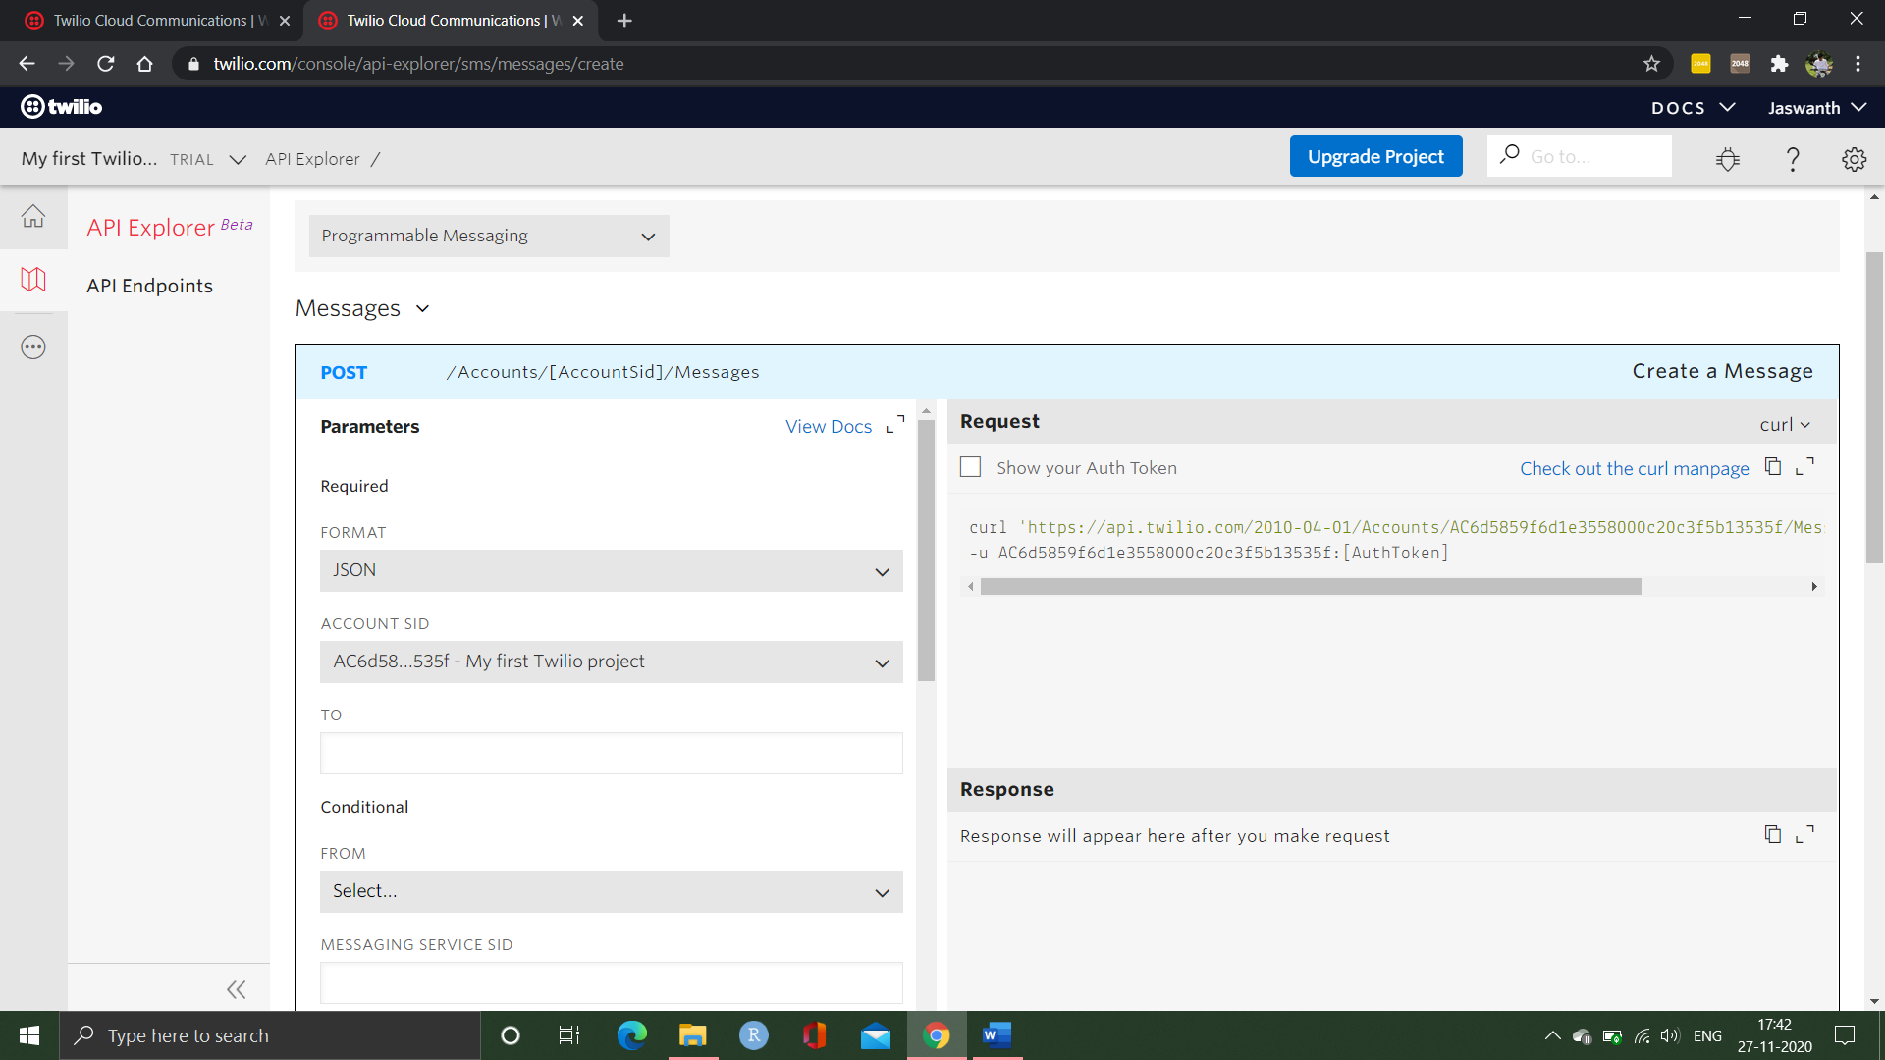

* After selecting the create message

Enter the mobile number of participants to whom you are sending the message.

Click on from drop box and select the trail number which we have created in step 2.

In the body dialogue box enter the message you are willing to convey.

Click on make request.

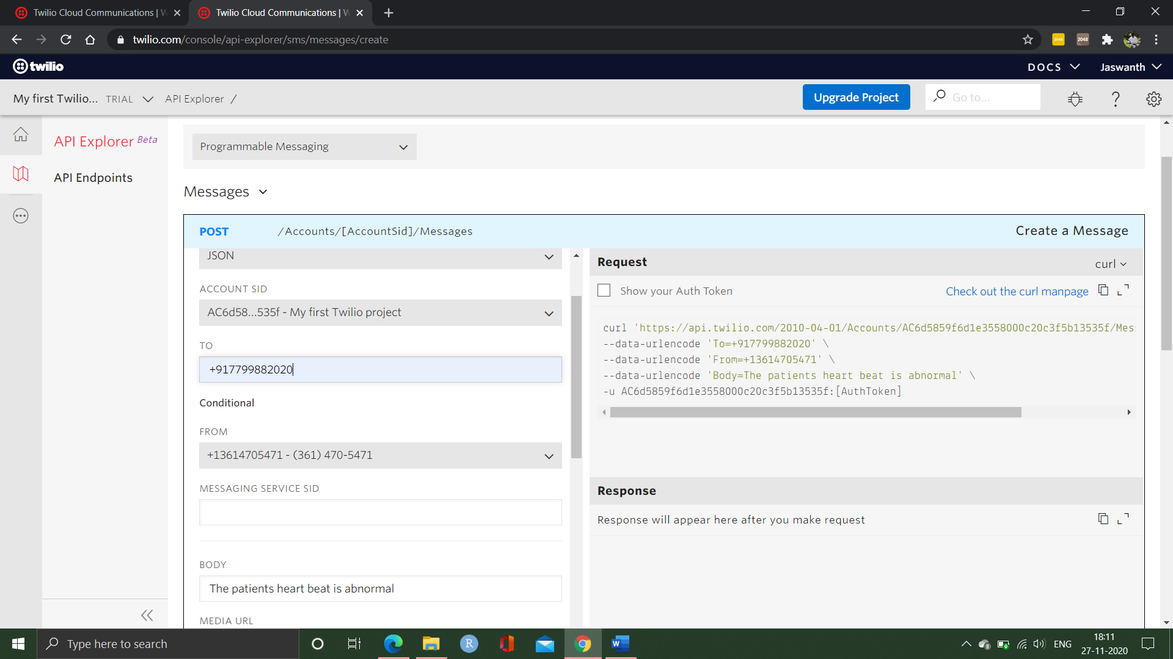

* After clicking on make request it will send the message to particular participant and will generate an account Sid and auth token.

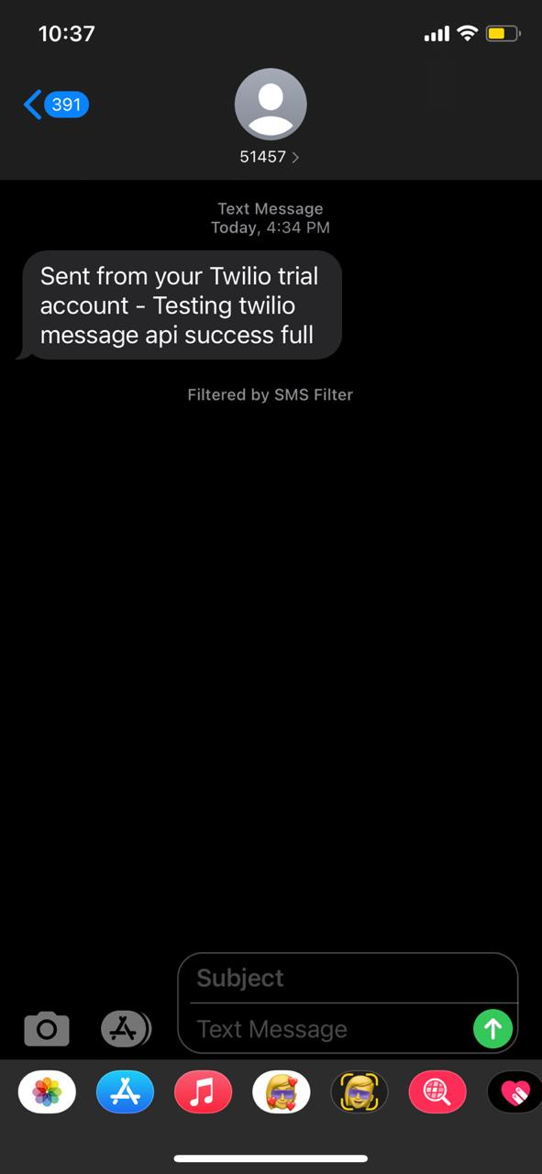

* We should save the account sid and auth token

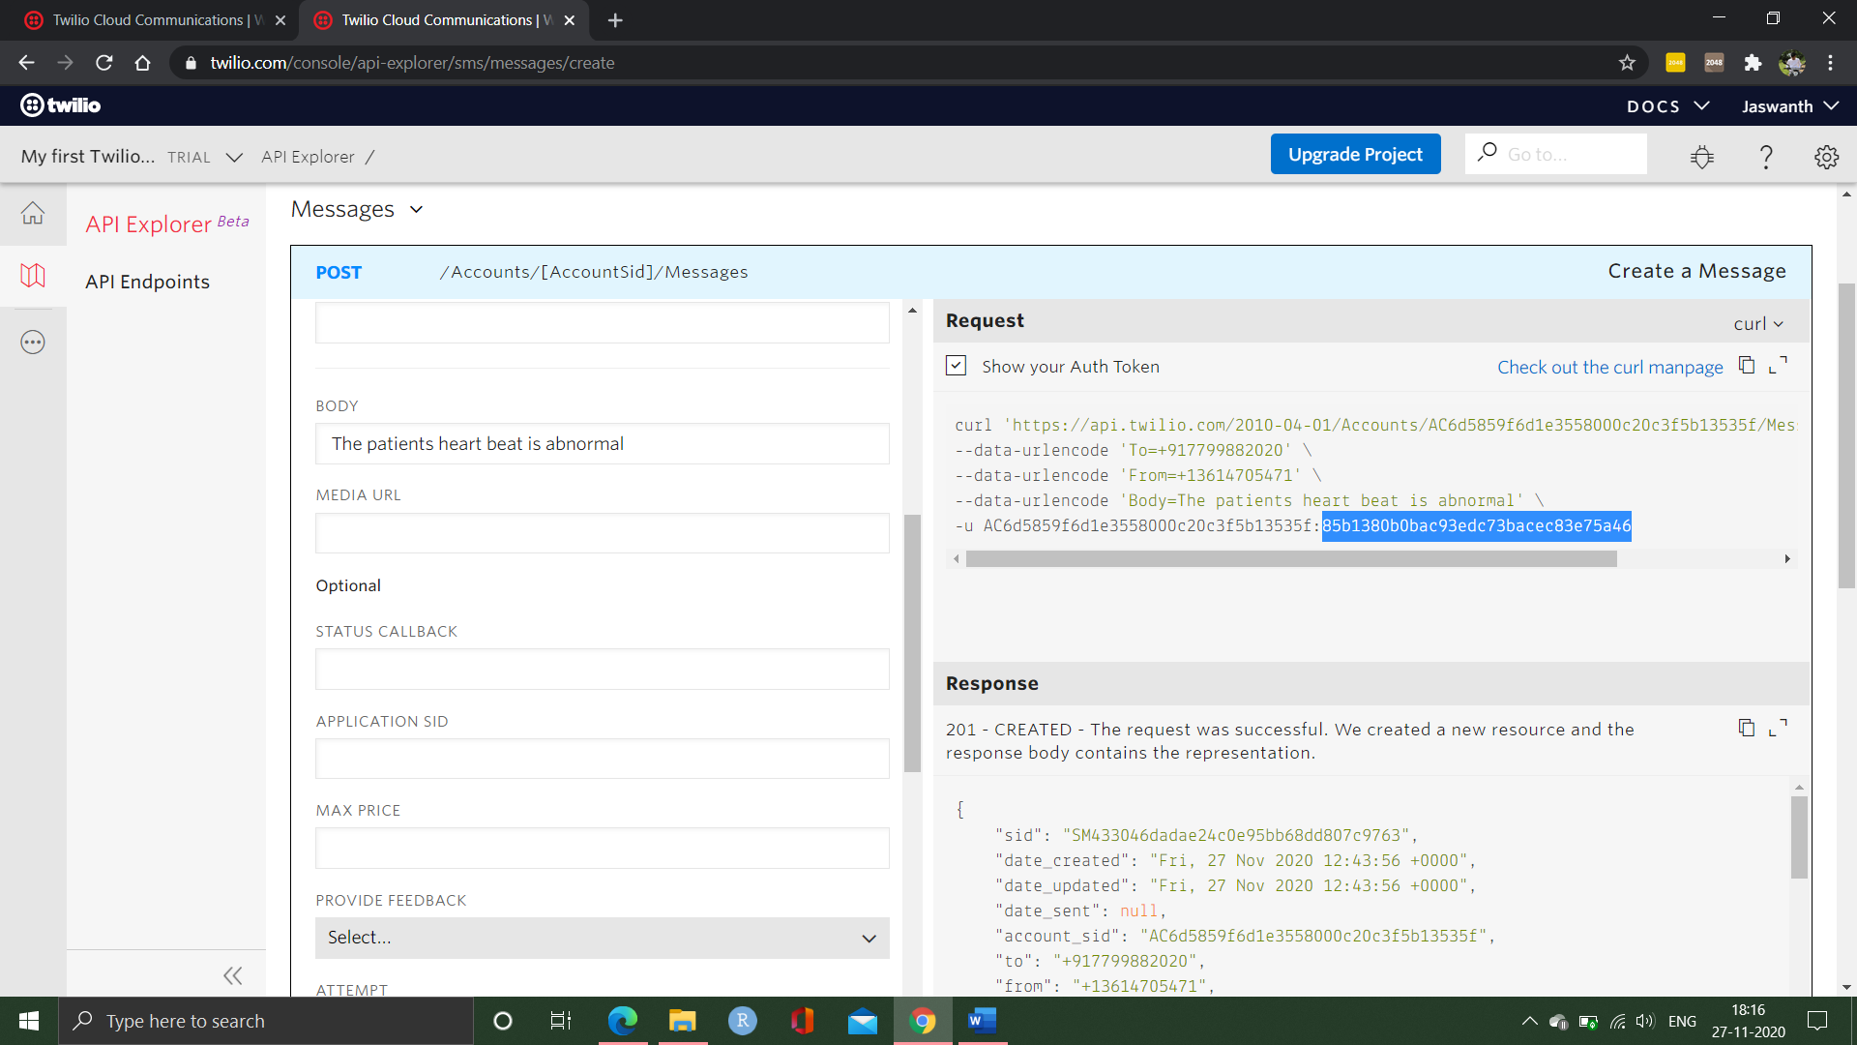

* Now we have to send this saved data to the AWS console.
  1. **– CODING IN AWS FOR CHECKING ABNORMALITY**
* First launch the instance and connect using putty. After connecting we import the packages which are required by the project the commands which are used are:

sudo apt-get-y update

sudo apt install python3-pip

sudo pip3 install boltiot

* After installation we must create two files one conf.py and other heart_rate.py in the aws vpc

sudo nano conf.py //file 1

sudo nano heart_rate.py //file 2

**CONF.PY CODE:**

#Credentials from Twilio

SID = SM2a4ab3f341c9462d9fe577b316e4aef5

AUTH_TOKEN = 85b1380b0bac93edc73bacec83e75a46

FROM_NUMBER = +13614705471

TO_NUMBER = +917702795929

#Credentials from Bolt

API_KEY = b8085155-c8b8-481d-84c2-9d8d95e6c5b9

DEVICE_ID = BOLT13168670

**HEART_RATE.PY CODE:**

import conf, json, time

from boltiot import Sms, Bolt

minlimit = 67 #the minimum threshold of heart rate

max_limit = 110 #the maximum threshold of heart rate

Mybolt = Bolt(conf.API_KEY, conf.DEVICE_ID)

SMS = Sms(conf.SID, conf.AUTH_TOKEN, conf.TO_NUMBER, conf.FROM_NUMBER)

while True:

response = Mybolt.analogRead('A0')

data = json.loads(response)

value1 = int(data['value'])

value1 = value1

print ("The current Heartbeat of patient is "+ str(value1)+" BPM”)

sensor_value=0

try:

sensor_value = int(data['value'])

except e:

print("There was an error while sending the response: ",e)

continue

try:

if sensor_value > max_limit or sensor_value < min_limit:

print ("The heartbeat is abnormal sending SMS")

response = SMS.send_sms("HeartBeat abnormal. The Current heartbeat is " + str(value1)+ " BPM")

print("This is the response for SMS ",response)

except Exception as e:

print ("Error",e)

time.sleep(10)

* Now we have all we need to execute our project run the code which is present in Arduino IDE software and come to putty and type the below command to execute the project.

sudo python3 heart_rate.py //running code

**EXPERIMENTAL RESULTS**

* 1. **– Arduino Output**

* 1. **– Execution in AWS VPS**

* 1. **– Twilio Execution**

* 1. **– Output received by Client**

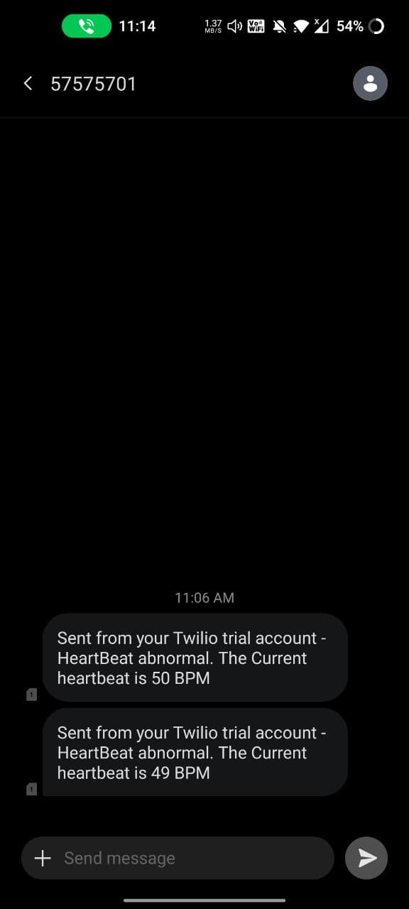

**DISCUSSION OF RESULTS**

* 1. **– ARDUINO OUTPUT**

1.In this figure we identify that a person is placed the finger in the sensor and it measures the blood flow of a person.

2.The blood flow which is detected by using the heartbeat sensor and it is a continuous process as we can see in fig 6.1.

3.By using the Wi-Fi module which it is connected to the Arduino board and pass the data to the amazon VPS.

4.The data which is collected from the heartbeat sensor passed to the amazon VPS(virtual private server).

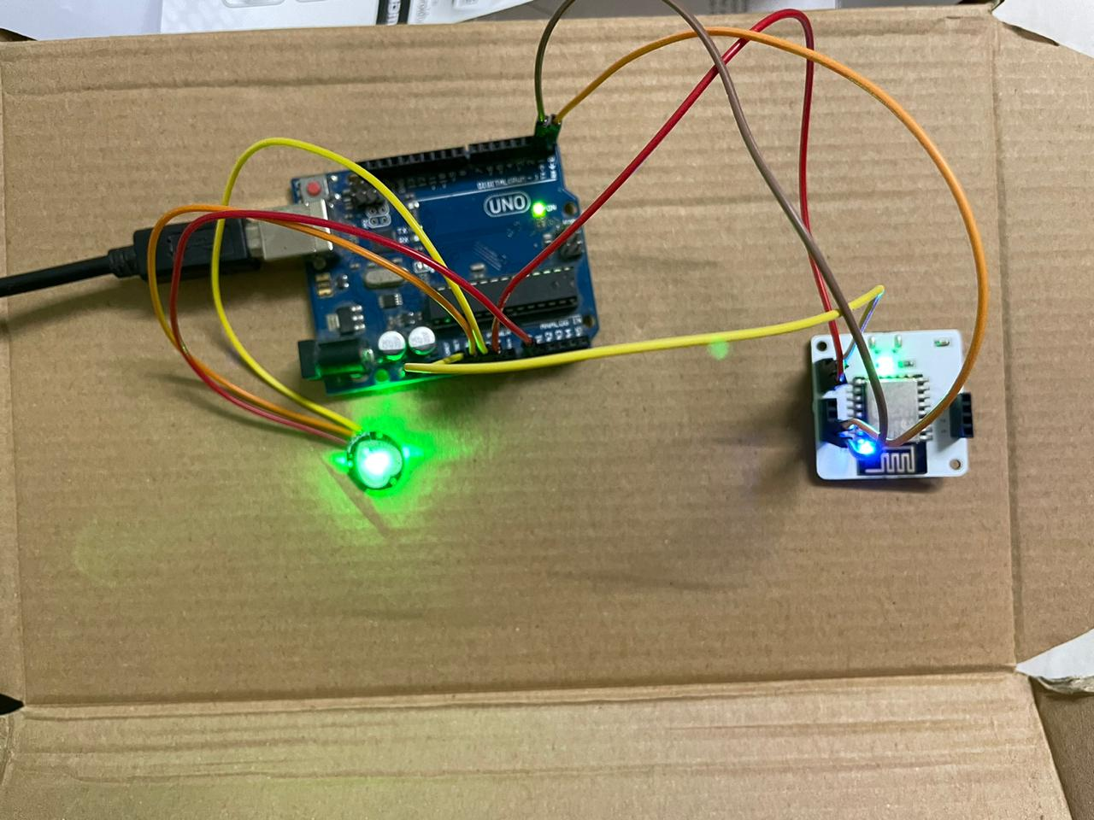

* 1. **– EXECUTION IN AWS VPS**

1.In this Fig-6.2 the data which is collected from the Arduino board and it checks the patient heartbeat pass the data to the VPS.

2.The heartbeat sensor which it collects the data from the patient and continuously check if there is abnormality in patient’s data.

3.If the patient abnormality is below 64 or above 110 automatically the virtual private server sends the message to the Twilio and Mailgun.

4.So that the virtual private service will automatically follow up the patient’s data to the Twilio and the Mailgun services.

* 1. **– TWILIO EXECUTION**

1. In this Automation services an API key generated which it is placed in the code and get a connection between the virtual private service and Twilio services.

2. In this service we must collect the patients phone numbers and the doctors phone numbers are saved in the Twilio monitor dashboard.

3. In this service if the patient abnormality is less than 64 and greater than 110 it delivers the message to the patient and doctors mobile.

4. The Twilio service sends the message like the patient abnormality is less and meet a consultant doctor and the doctors phone number will be send to the patient.

5. As we can see in fig 6.3 it also displays the status of the message whether it is delivered or not.

**7.4 – OUTPUT RECEIVED BY CLIENT**

1. The message is received from the Twilio which it shows that the patient condition is not in normal condition.

2. It also displays the abnormal heartbeat of the patient and the patient so the doctor can check upon the patient as soon as possible. (Fig- 6.4)

**CONCLUSION AND FUTURE SCOPE**

This covid-19 pandemic has caused many problems to everyone and especially the most affected ones are the patients. Patients whose heart pulse needs to be monitored regularly by the concerned doctors are affected by this Covid-19 outbreak. There has been a communication gap formed between these patients their concerned doctors/caretakers. Due to the implementation of lockdown all over the world, the situation got worse for the patients. This is where our idea flourished to help those section of patients whose heart pulse needs to be monitored regularly. With the help of the knowledge we gained from the concepts of IOT and its applications in medical field, we have researched and studied many research papers related to our problem statement. After reviewing many papers, finally we have chosen one paper as our base paper and started working on the idea. Our project “Heart Pulse Detection and Notification System using Arduino” mainly focuses on the communication gap between the patients and their doctors. The main aim of our project is to establish a communication bridge between the patients and the concerned well takers/doctors. We have used reliable components such as Arduino uno, which is the brains of our system, KY039

heart pulse sensor, which detects the heart pulse of the body, and BOLT Wi-Fi module for establishing a connection to send data through the internet. We have used the most reliable VPS service provider which is the AWS VPS to run the program(code) required to detect the abnormality present in the heart pulse. For the notification module, we have used TWILIO as our online API service which sends data to the concerned doctor whenever there is an abnormality present in the patient’s heart pulse.

**USER STORIES**

1. As a developer of this project, I will do my best to provide users of this project a simple, seamless and an automated experience.so that the users of the project will not have any trouble using it.
2. As a patient, I should be able to view my readings and I should receive immediate assistance. So that if there is any emergency the doctor should come to know about this, and I should receive assistance immediately.
3. As a doctor, I should be able to monitor my patients without any interruption and should be notified immediately if there is any anomaly in my patients’ statistics. So that I provide my assistance to the patient.

**REFERENCES**

1. Remote Patients Monitoring System(Heartbeat and Temperature) using Arduino,Ruaa

Shallal Abbas Anooz, Methodology -using IOT. Published - August 2018.

Reference link- [www.researchgate.net/publication/330666824](http://www.researchgate.net/publication/330666824).

2. Analysis of Heart Rate and Body Temperature from the wireless monitoring system

using Arduino,Mohammad Dabbagh. Methodology – using IOT. Published –

Nov2019

Reference link- [www.researchgate.net/publication/337116465](http://www.researchgate.net/publication/337116465).

3. Continuous Heart Rate and Body Temperature Monitoring System using Arduino

UNO And android device, Asaduzzaman Miah, Hussain Kabir,Siddiqur Rahman

Tanveer ,M.A.H. Akhand. Methodology – using IOT. Published – 2015 second

International conference on electrical information and communication technologies.

Referencelink- <https://ieeexplore.ieee.org/document/739194>

4. Developing IOT Based Smart Health Monitoring Systems: A Review, Ashikur

Rahaman, Muhammad Sheikh Sadi, Sheikh Nooruddin. Methodology – using

IOT.published-september2019,

Referencelink- [www.iieta.org/journals/ria/paper/10.18280/ria.330605](http://www.iieta.org/journals/ria/paper/10.18280/ria.330605)

5. Smart Healthcare Monitoring using IOT, ShubhamBanka, Isha Madan

and S.S. Saranya. Methodology – using IOT. Published – January 2017.

6. Development of smart health care monitoring system in IoT environment, Md.Milon

Islam, Ashikur rahaman, Md.rashedul Islam. Methodology – using IOT.published-

May2020.

Referencelink - link.springer.com/article/10.1007/s42979-020-00195-y

7. Low cost Heart rate Portable Device for the Risk patients with IOT and warning

system,Muhammad Irman, Era Madon. Methodology-using IOT, published-June 2018

Referencelink - ieeexplore.ieee.org/document/8686761

8. An IoT-Based Smart Framework for Human Heartbeat Rate Monitoring and Control

System,Sani abba, Abubakar Mohammed garba. Methodology -using IOT.published-

November 2019

Reference link - www.researchgate.net/publication/337275306

9. IoT Based Heart Activity Monitoring Using Inductive Sensors, Adrian Brezulianu,

Oana Geman. Methodology-using IOT, Published-26 july 2019.

Reference link- <https://www.mdpi.com/1424-8220/19/15/3284>

10. A smart system for remote monitoring of patients and SMS messaging upon critical

Condition Angad Kale, Siddharth.K. Kaul, Debi Prasad Das and S. Raghunath.

Methodology-using IOT, published-2007

Reference link - ieeexplore.ieee.org/abstract/document/4475765

11. Web-based remote monitoring of infant incubators in the ICU,D.I. Shina, S.J. Huha,

T.S. Lee , I.Y. Kimc. Methodology-using IOT, Published-September-2003

Reference link - pubmed.ncbi.nlm.nih.gov/14519407/

12. Applying Telecommunication Technology to Health, James C. Lin, Methodology-

using IOT, published-August-1999.

Reference link - ieeexplore.ieee.org/document/775486